**MIDDLE EAST TECHNICAL UNIVERSITY**

**DEPARTMENT OF ELECTRICAL & ELECTRONICS ENGINEERING**



**TROY TECH**

**WEEKLY REPORT #8**

**05.04.2019-09.04.2019**

**Section :** 7

**Studio Coordinator:** Mustafa Mert ANKARALI

**Partners :**

Hasan ÖZKARA - 2031888

Kağan ÖZASLAN - 2031854

Caner POTUR - 2031250

Mustafa Ercan OKATAN - 2031193

Mert KAYIŞ – 2030997

**Progresses for Previous Week:**

* We made communication tests after implemented the all the subsystems to the body. We tested it at D-building. We had approximately 60 m range for both command and video transfer.

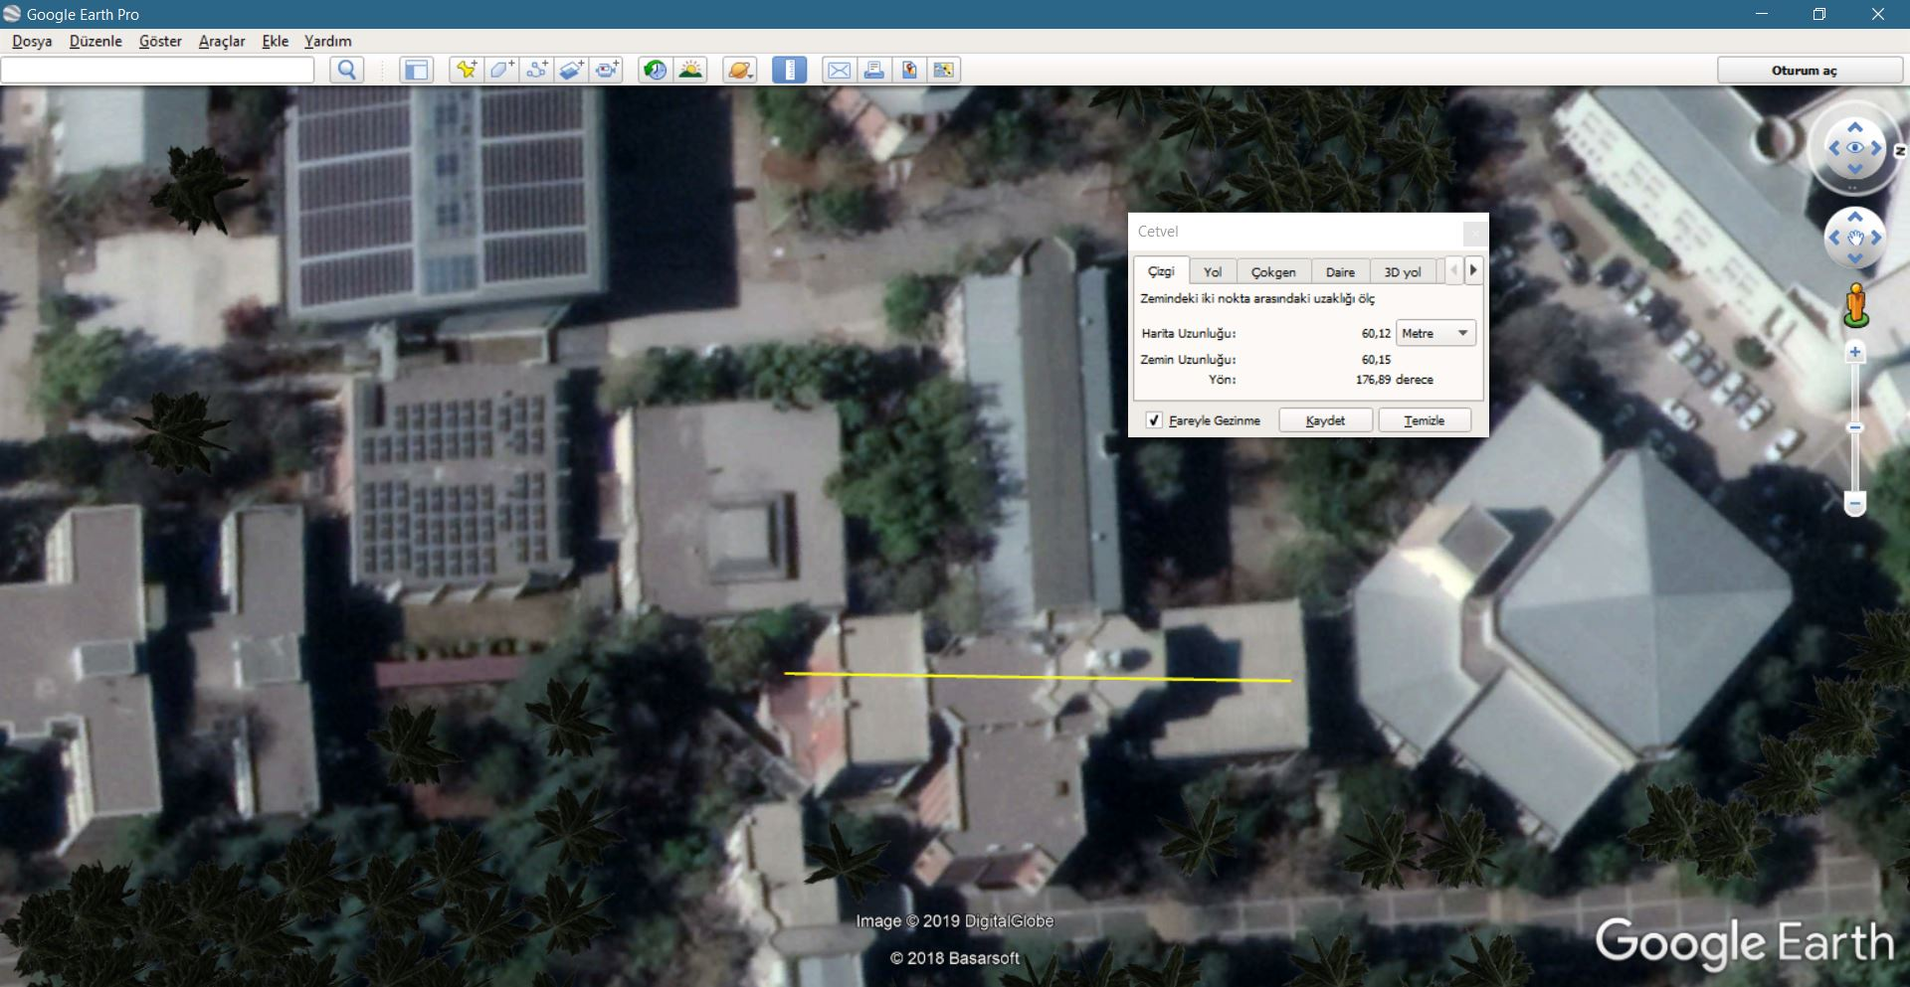

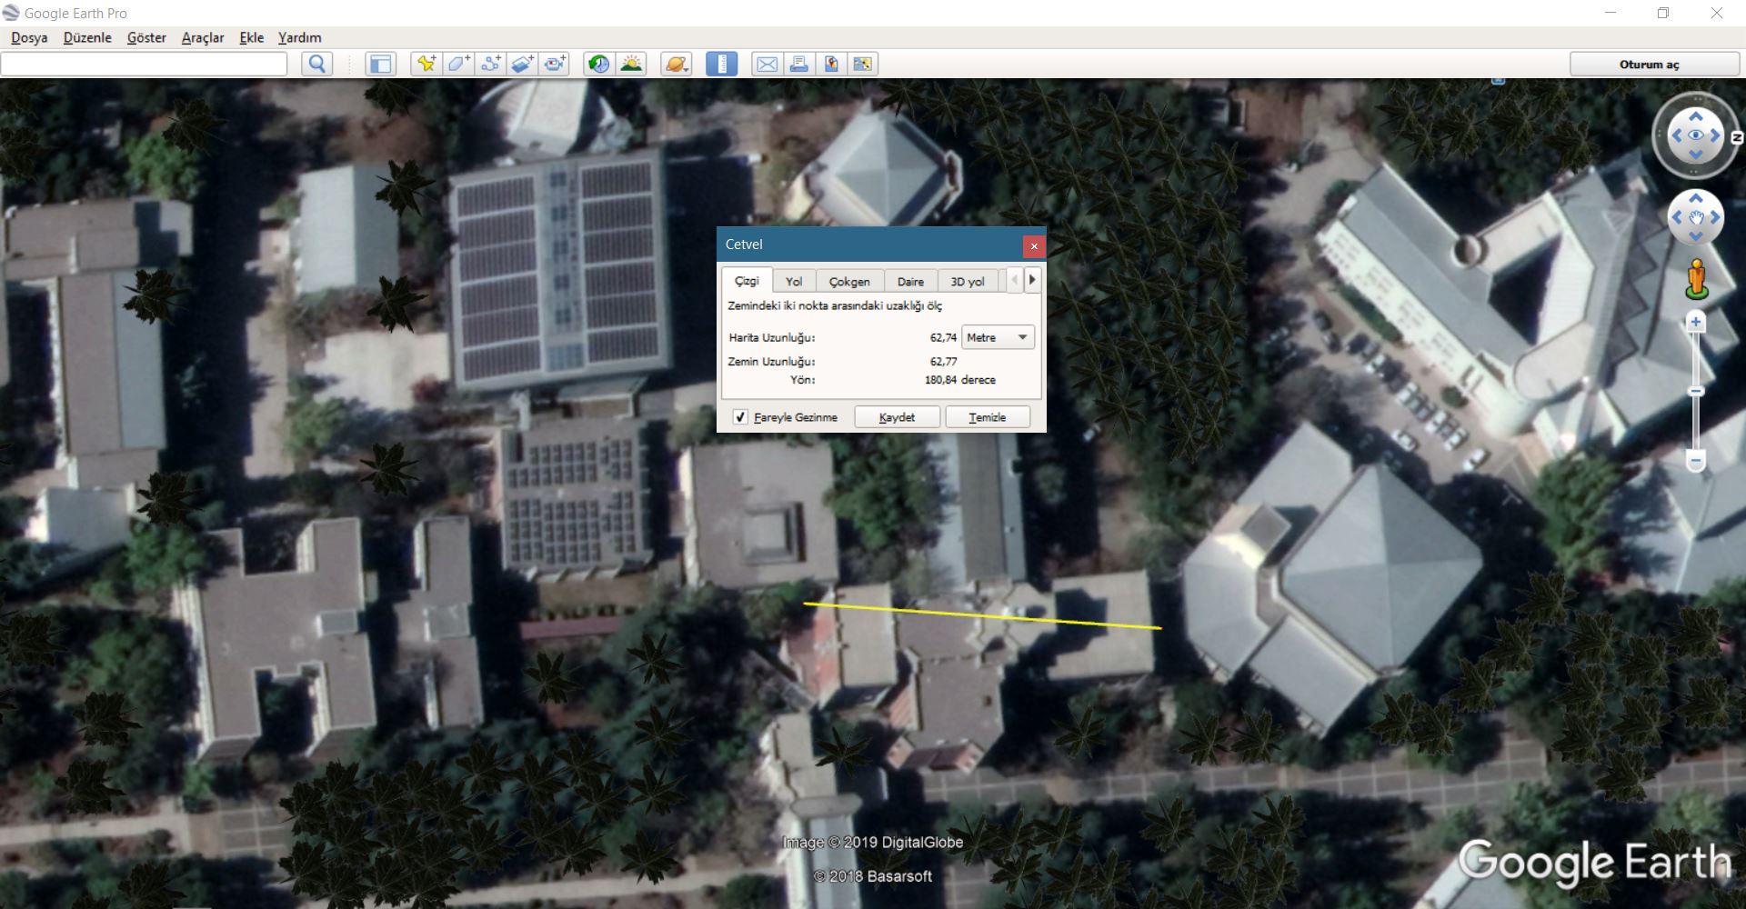

* We used an L-shape metal in order to mount the camera to the body. We located this connection piece just above the solenoid and in front of the accumulator. We bended the L-shape metal and changed its angle to 115 degree in order to have the best camera view.

